# **Browser Testing**

## **Chrome**

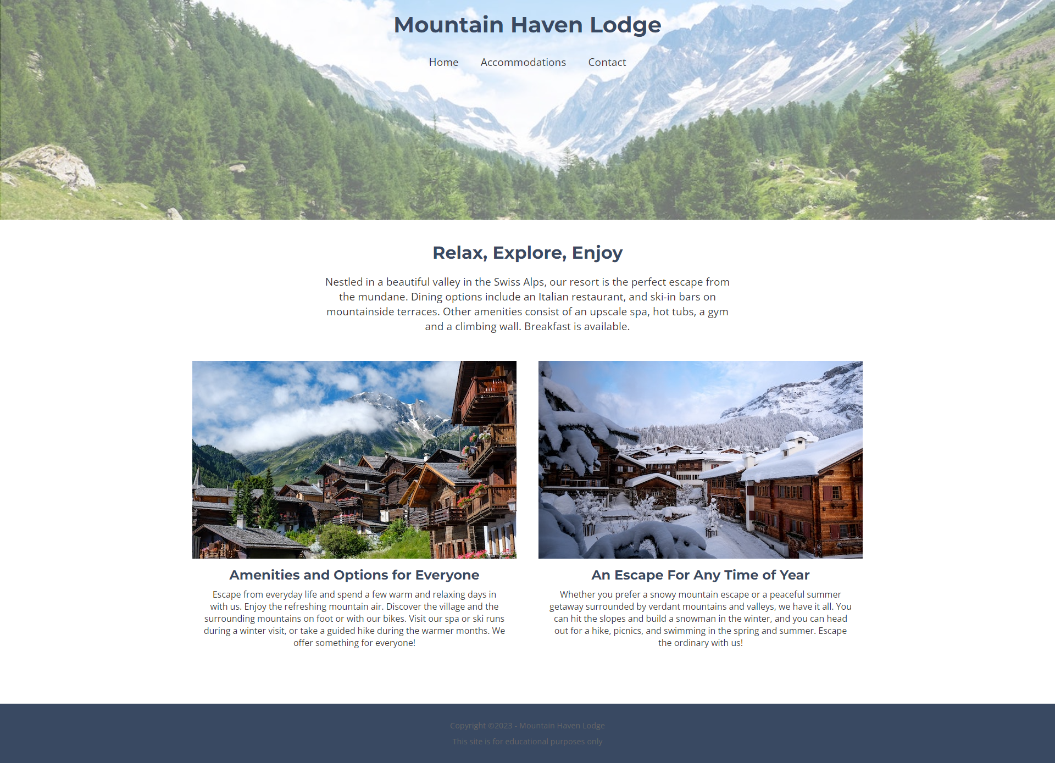

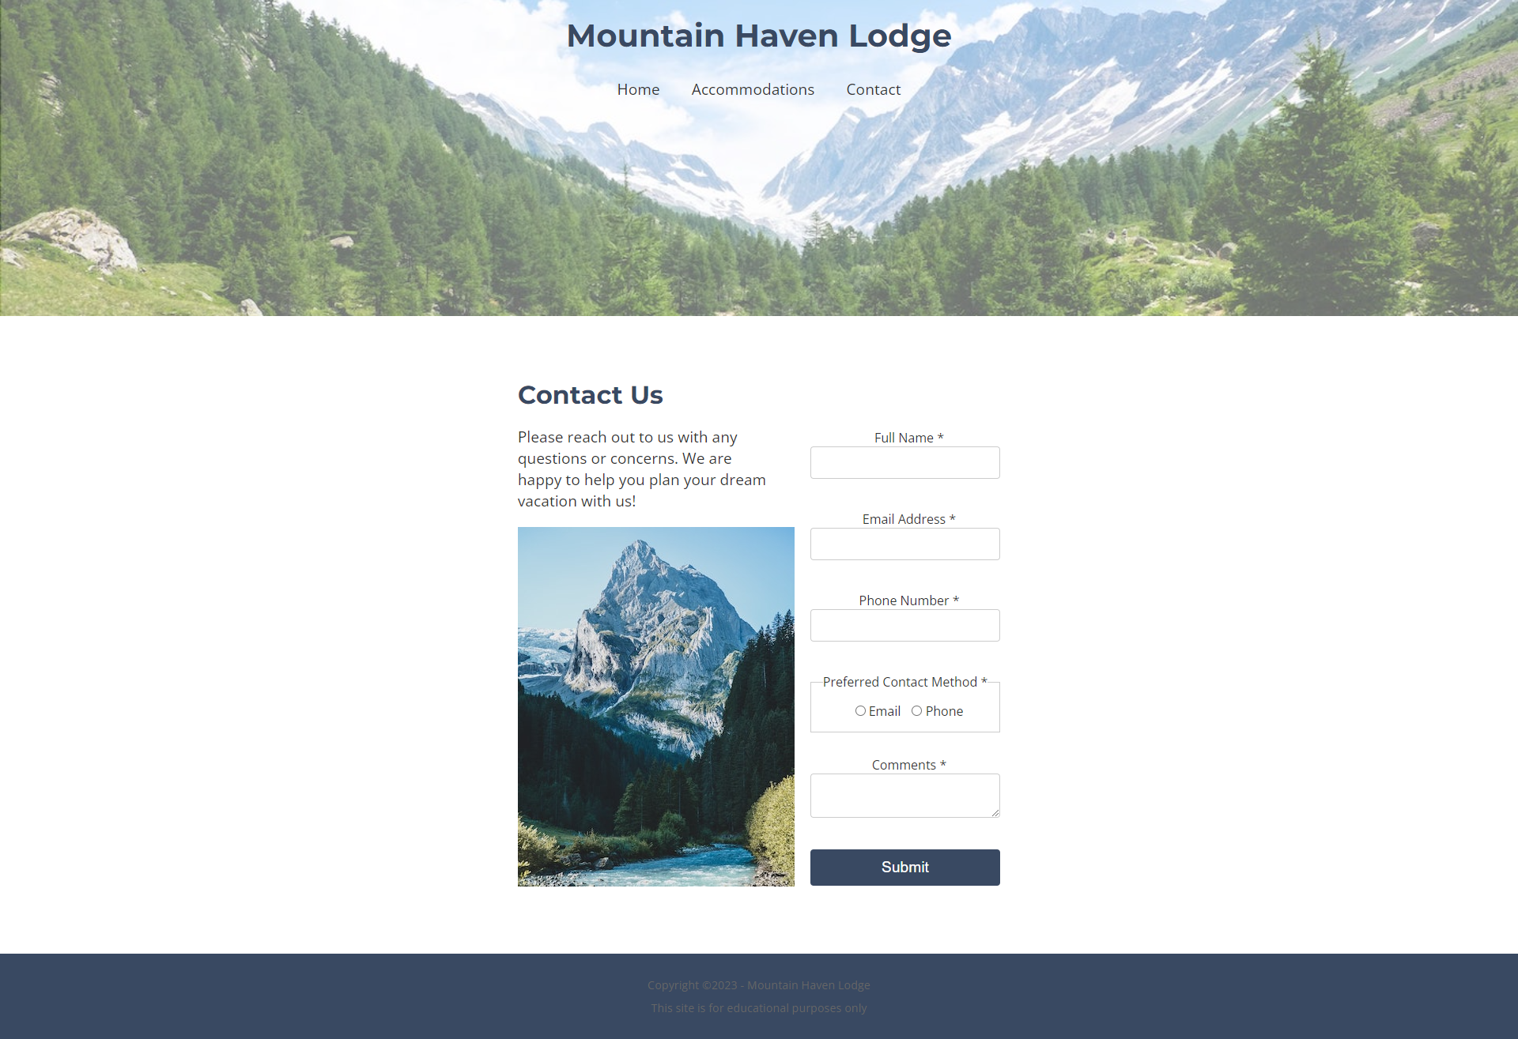

## **Mozilla Firefox**

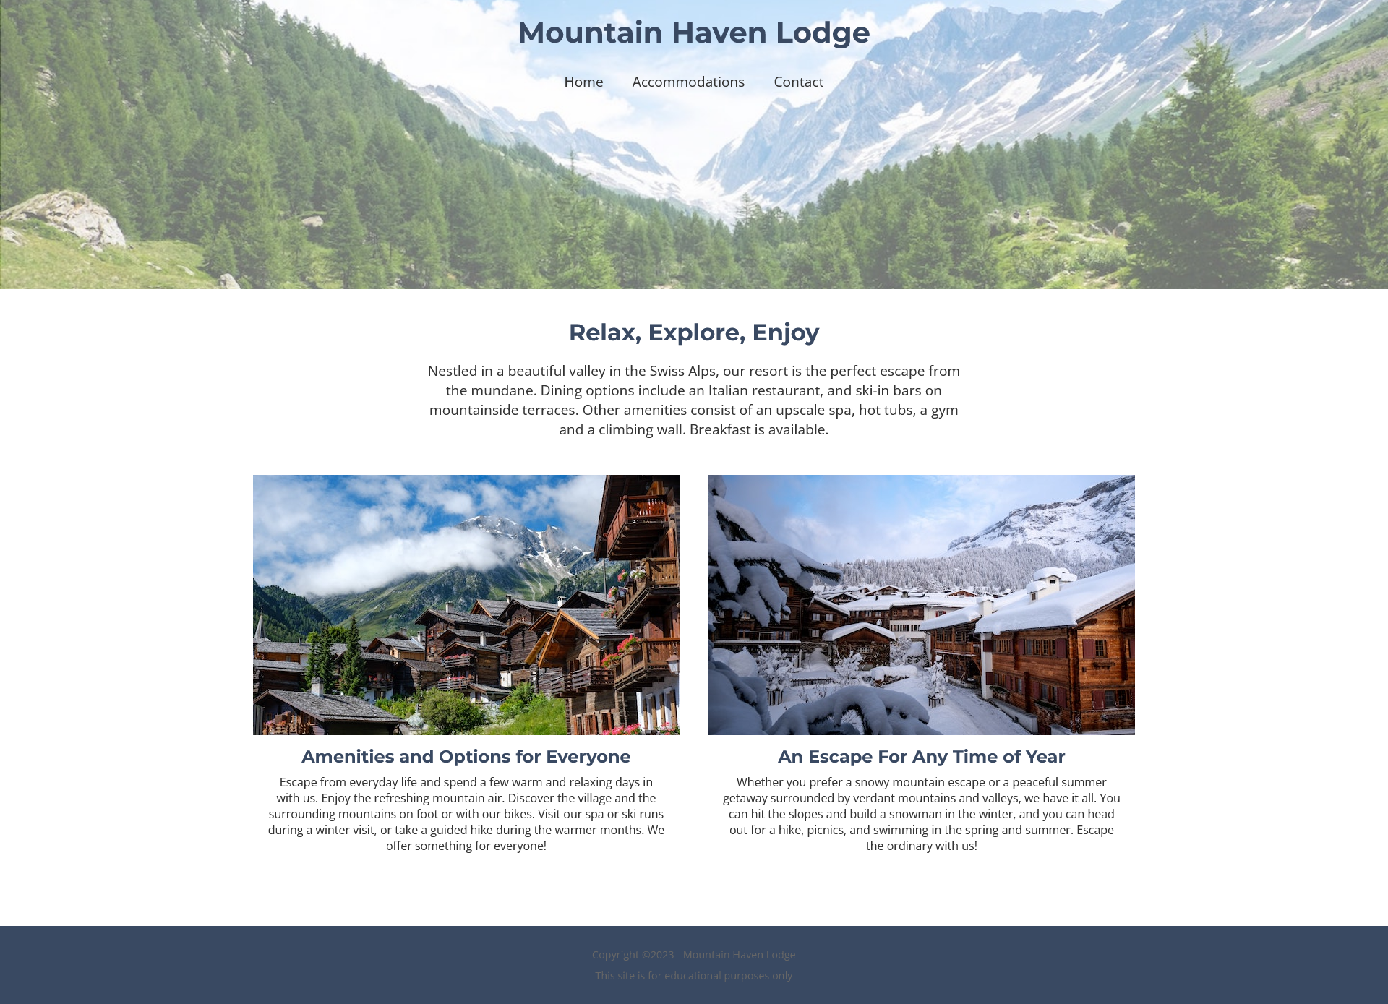

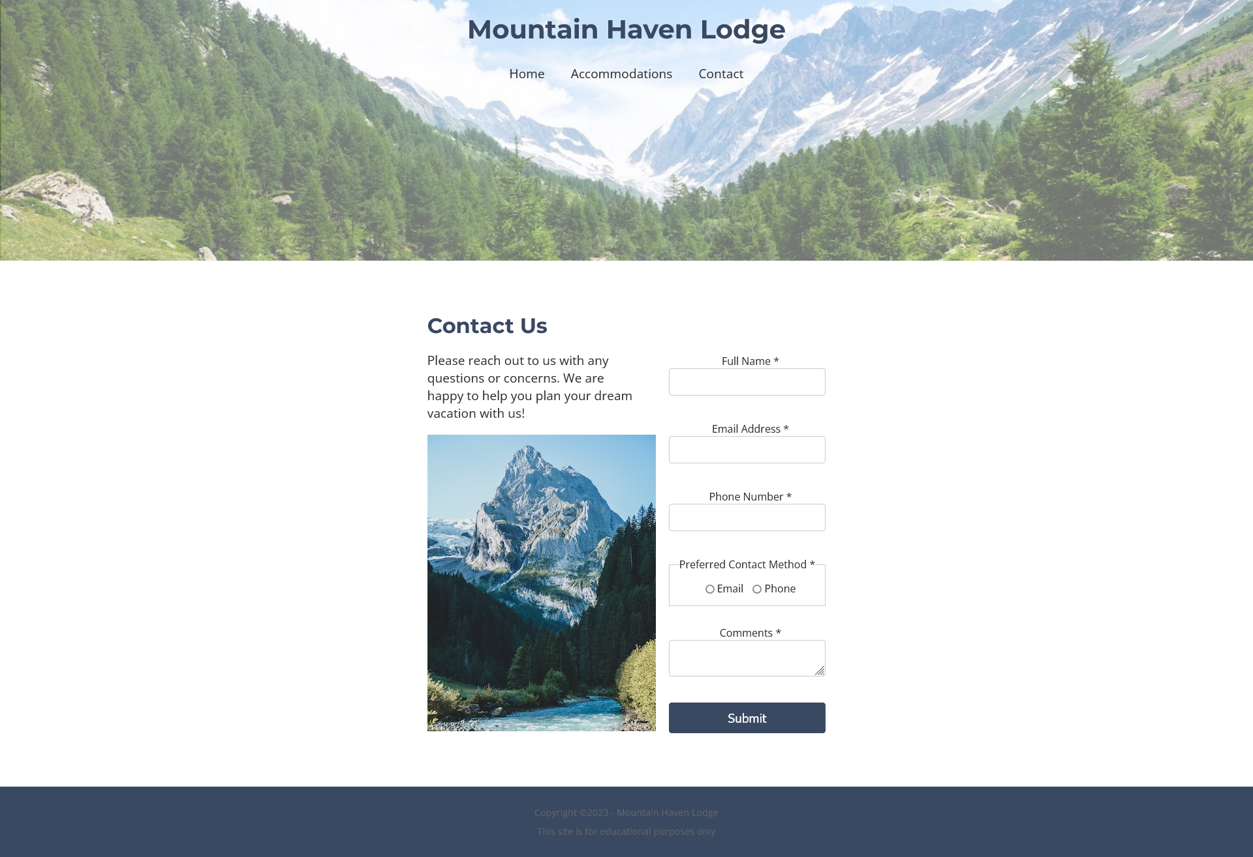

## **Microsoft Edge**

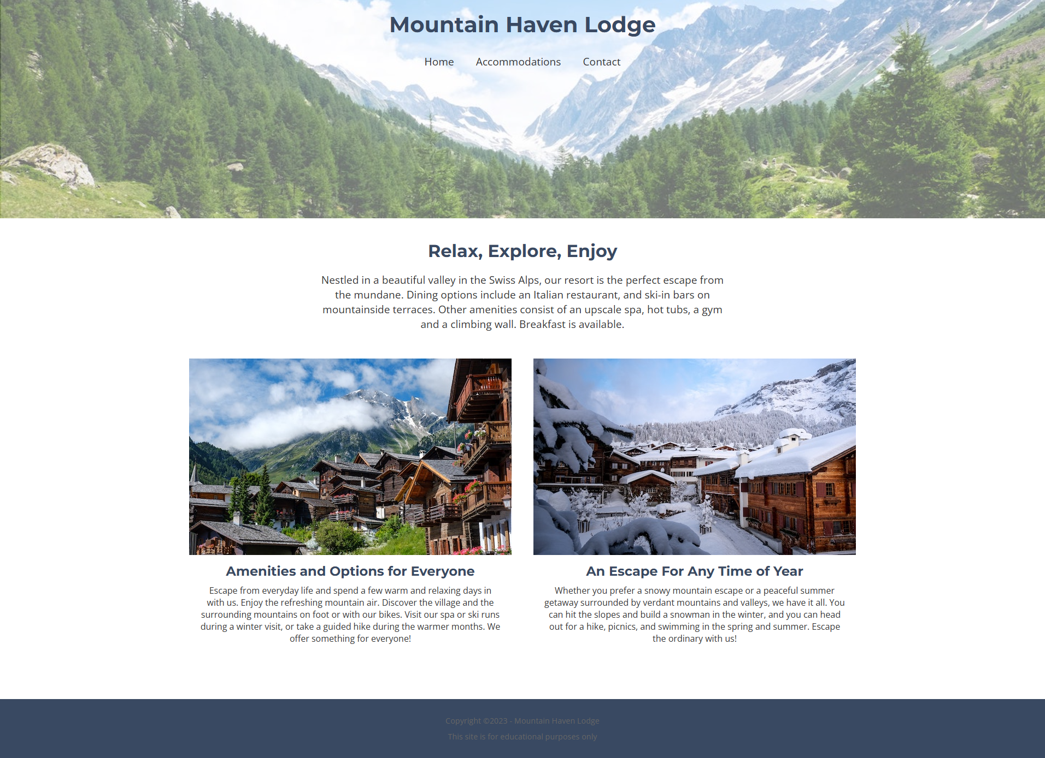

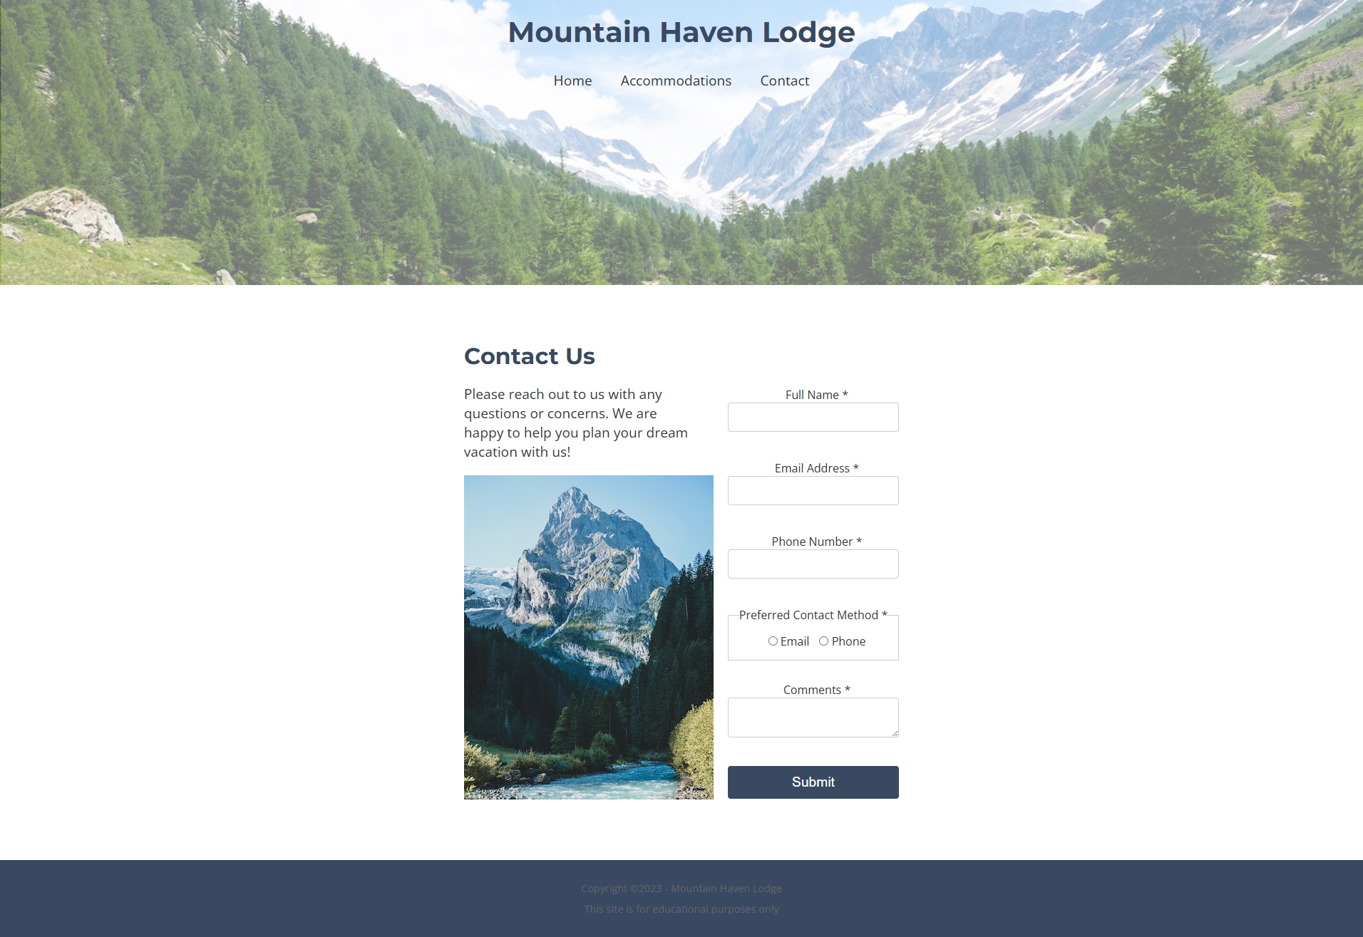

**Form elements**

The focus outline when clicking into a form field also appears as a distinct blue glow in Firefox, in contrast to Chrome and Edge’s black outlines. Edge shows the least visible box lines.

**Links**

The links and hover states appear to look the same to me across different browsers. However, what you naturally can’t see in the screenshots are the css hover styles, where a smooth underline transition appears when you hover your mouse over it.

**Fonts**

The title, navigation, h2, and paragraph text are most legible across all browsers. The form text is least visible across all browsers because of its size. Font rendering in Firefox tends to be slightly sharper and more defined.

**Colors**

The colors look the same to me across the board.